Lemmi

User Interface Prototype Document

Version 1.0

Revision History

| **Date** | **Version** | **Description** | **Author** |
| --- | --- | --- | --- |
| 11/12/2021 | 1.0 | UI screens and UI demo | TNMKhoa  MTCVan |

Table of Contents

1. Set of screen 4

2. Extra 14

3. Video demo 15

User Interface Prototype Document

# Set of screens

**1.1 Log in screen:**

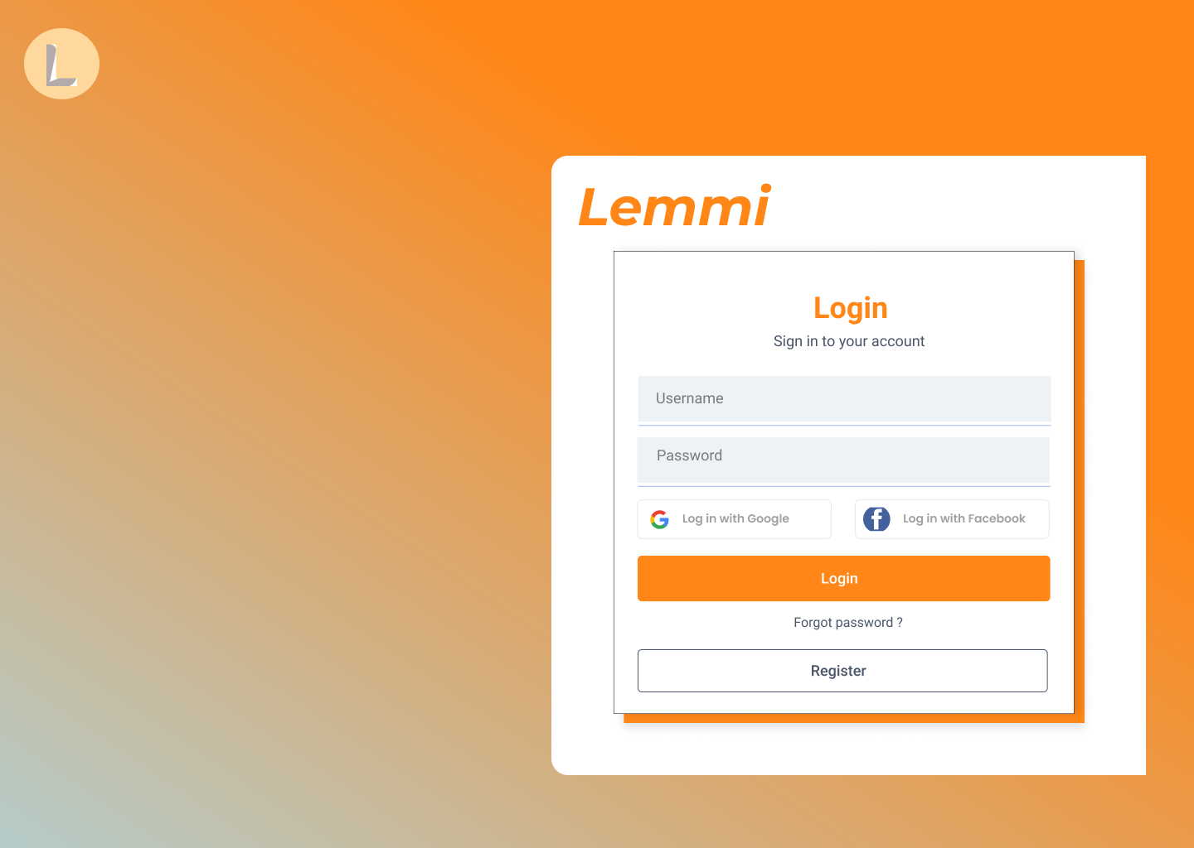

* Purpose: Log in to users’ accounts to use certain features that only authenticated users can.
* Show: A card with two inputs of the user's account name and password; two buttons to log in with Google or Facebook.
* How to use:
* If users have already registered with a third party, they can click these buttons to select the account to log in.
* Otherwise, users have to fill in all the blanks with the username and password registered on our website, and then click the “Login” button.
* If users do not remember their password, they can click “Forget Password?” for us to help them find it again.
* Choose account type to create when clicking the “Register” button: 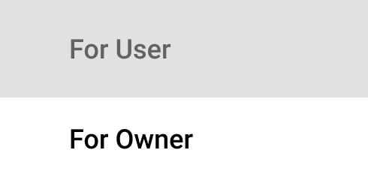

**1.2 Forgot password screen:**

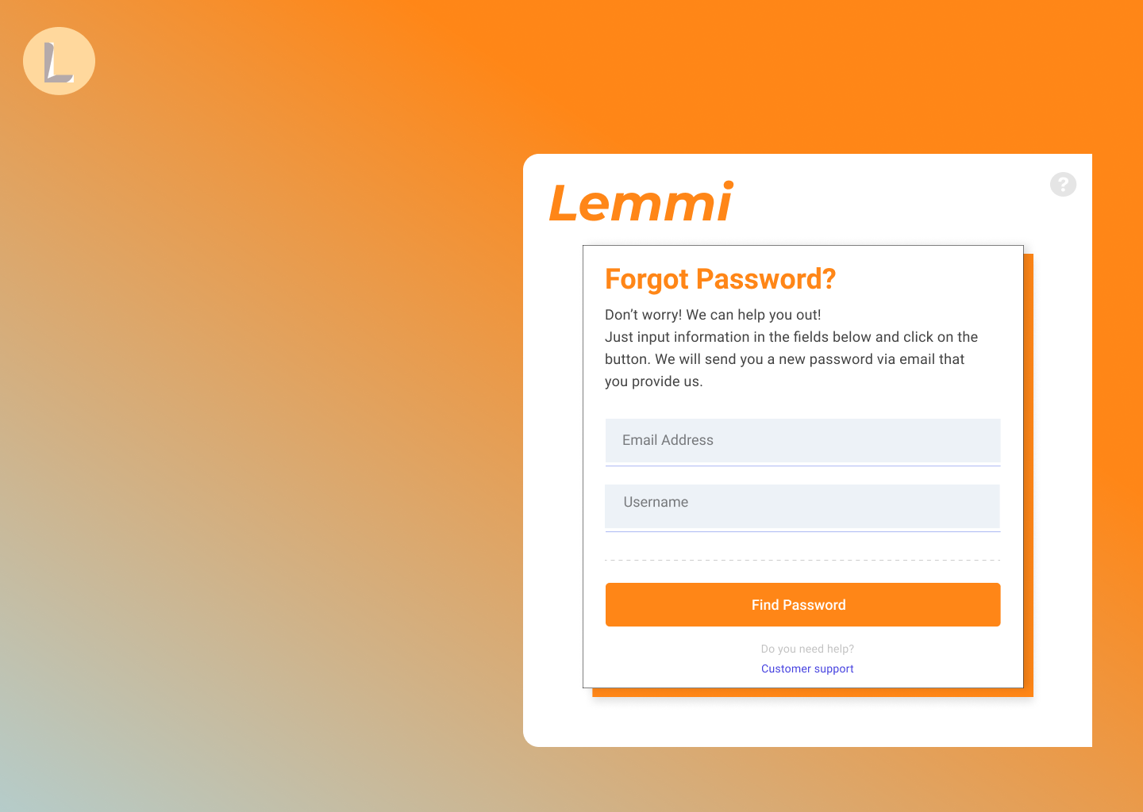

* Purpose: Restore password and get back account when user forgot password.
* Show: A card with two inputs of the user's email address or account name.
* How to use:
* Users can fill in the email address or username registered on the website and click the “Find Password” button.
* We will send them a new password via the email which they already input or linked to their account previously.

**1.3 Sign up screen for user and for owner:**

### 

* Purpose: Create an account to use the website’s authenticated functionalities.
* Show: A form with various inputs of the user's information. There are also two buttons to create an account with Google or Facebook.
* How to use: As a user or an owner, they have to fill in all required fields then click the “Create Account” button to finish this process.

**1.4 Homepage screen:**

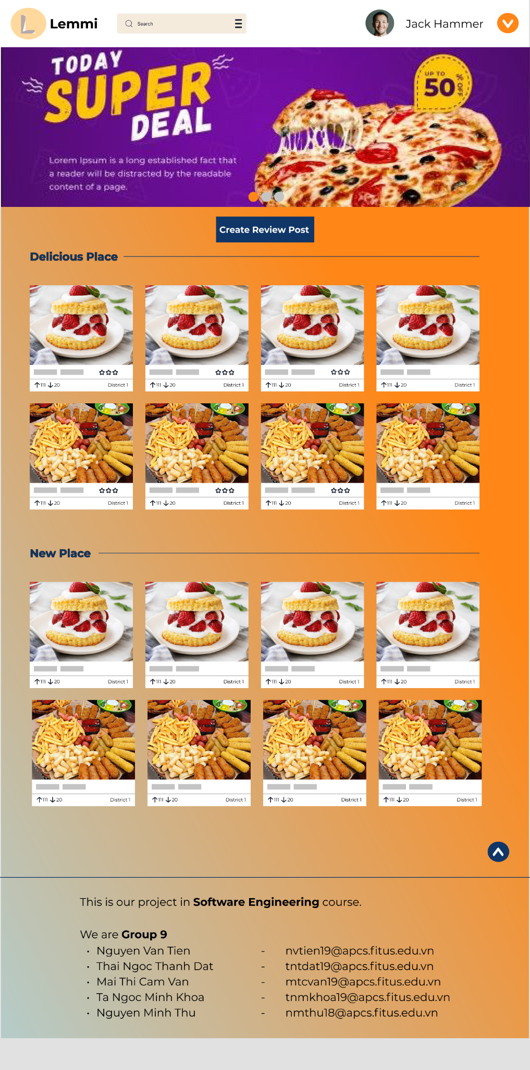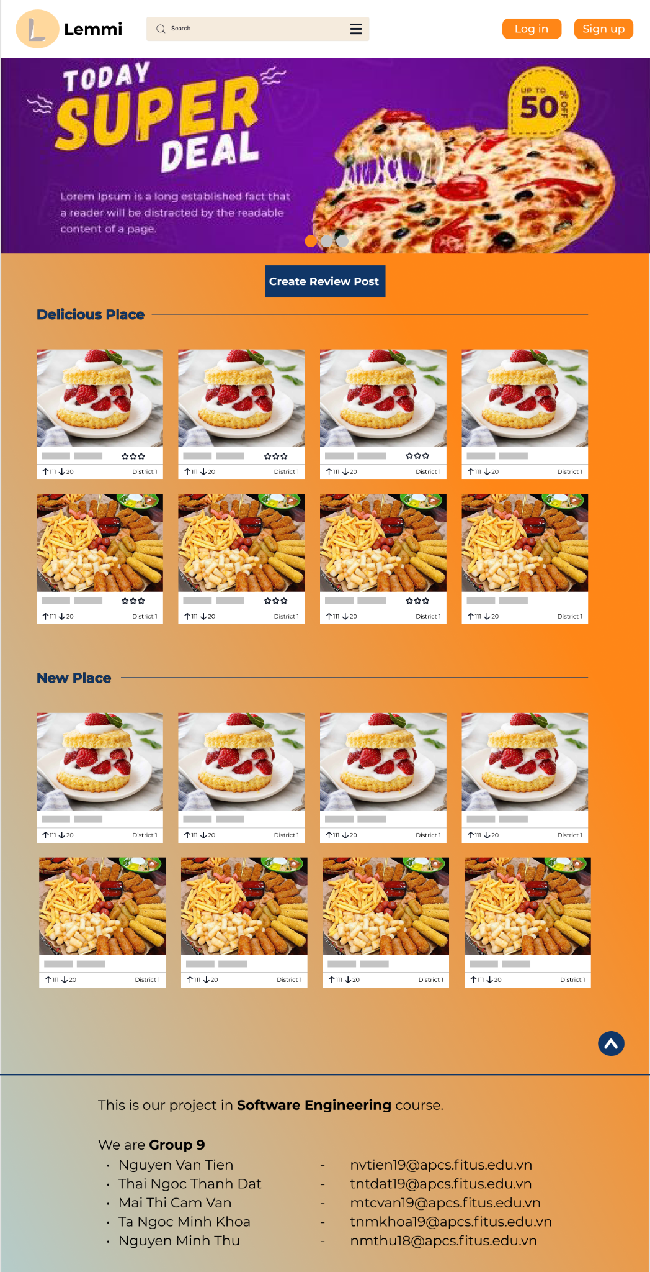

* Purpose: Provide users with an overview of the website.
* Show: There are many lists of cards with featured review posts including basic information such as district, rating star, the number of votes up/down, and some labels. Additionally, there is a “Create Review Post” button and a header with a logo section, search bar, account section.
* How to use:
* Scroll down to view posts and click the up arrow on the right-down corner to go to the top of the page. Users can click on any interesting post to go to the detailed post screen of that post.
* When users click the logo section, the homepage will be reloaded.
* When authenticated users click on an avatar, they will move to their profile screen.
* With guests, if interested, they can click the sign-up or sign-in button to be one of our members using other features.
* Only authenticated users can move to create a post screen when clicking the “Create Review Post” button.

**1.5 Post detail screen:**

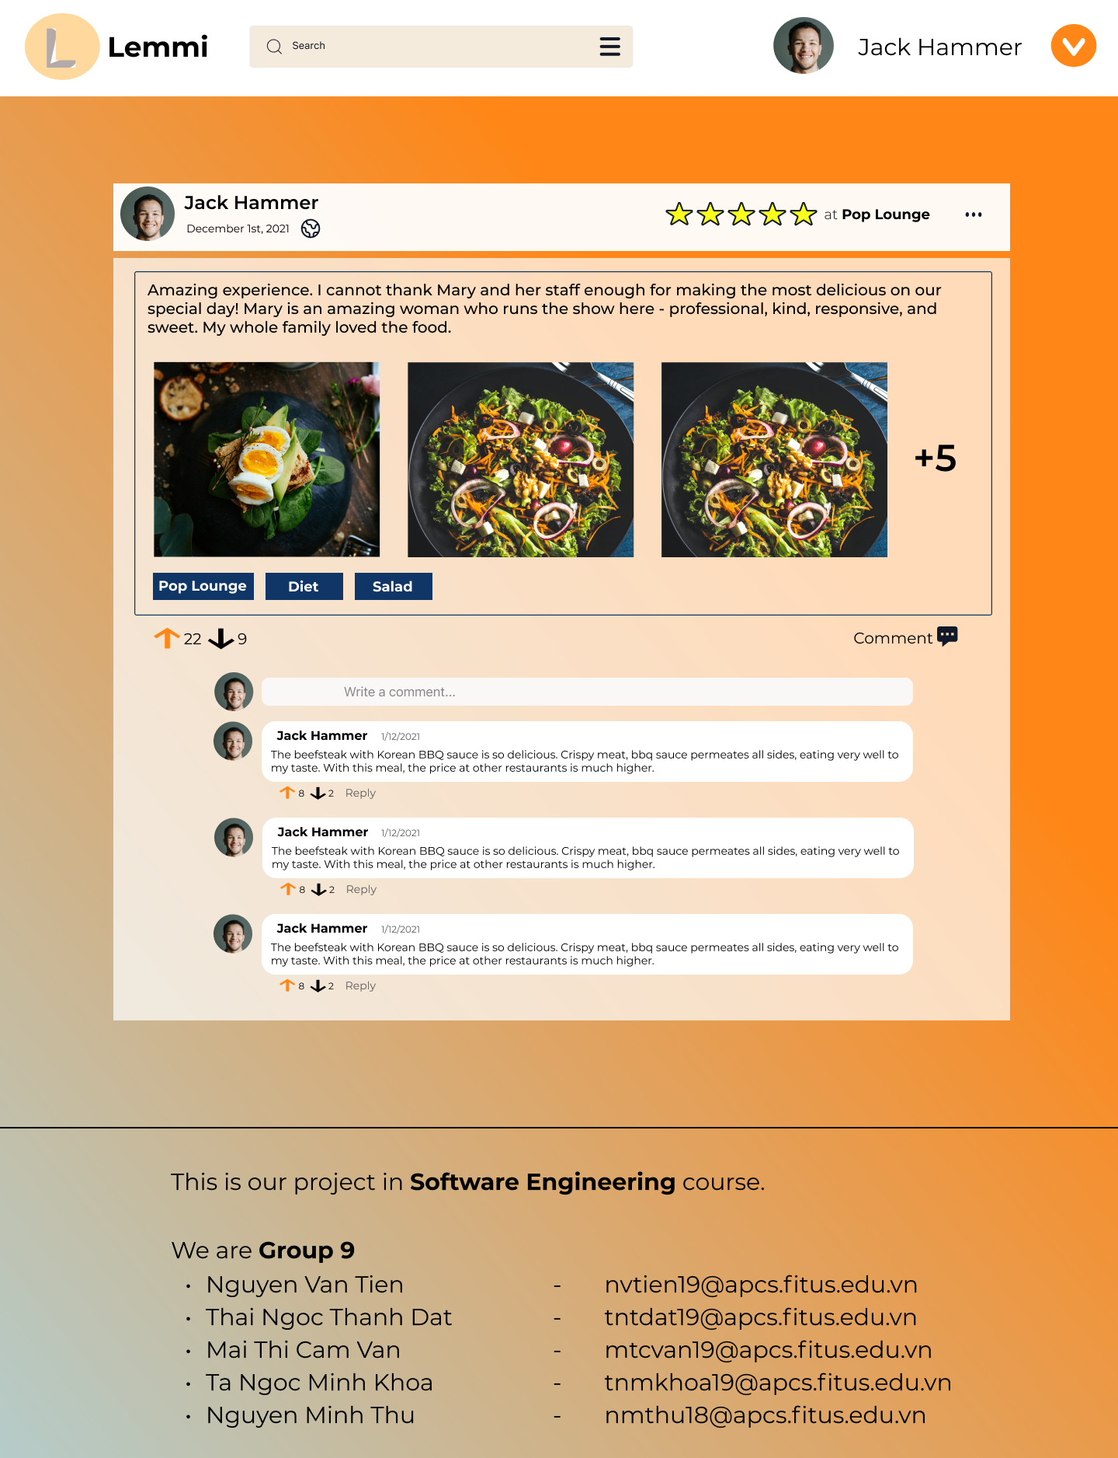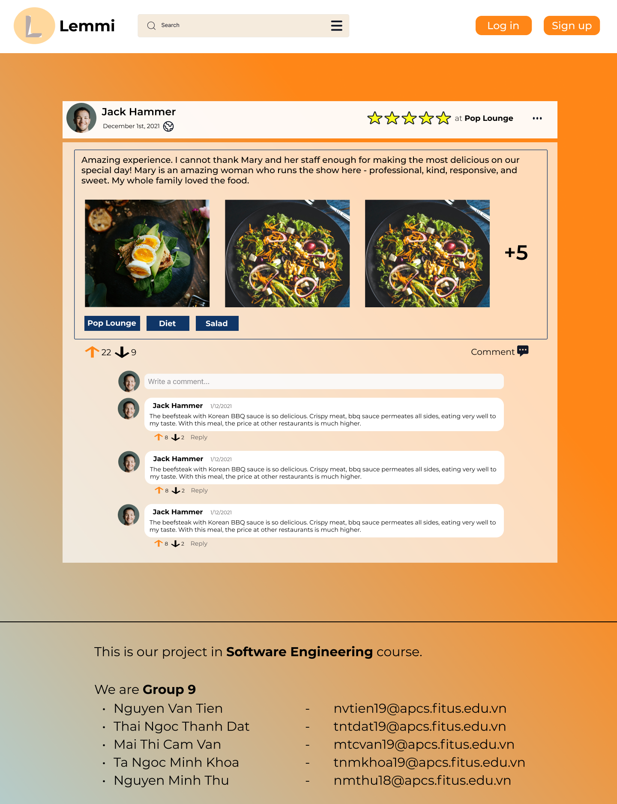

* Purpose: View a post review in more detail and interact with the post, comments below by voting, commenting, and sharing.
* Shows: Post detailed info such as the reviewer, date, post’s mode, rating star, caption, images, and all labels. Additionally, there are many interactive aspects such as upvotes, downvotes, and comments in a post.
* How to use: Only authenticated users can
* If reviewers post more than 3 images, users need to click on “+5” to view 5 remaining images.
* Click the comment field to express your opinion to the review/comment
* Click the upvote, downvote button on the left to react to the review/reply.
* Click the ⋯ to call report pop-up.

**1.6 Create post screen:**

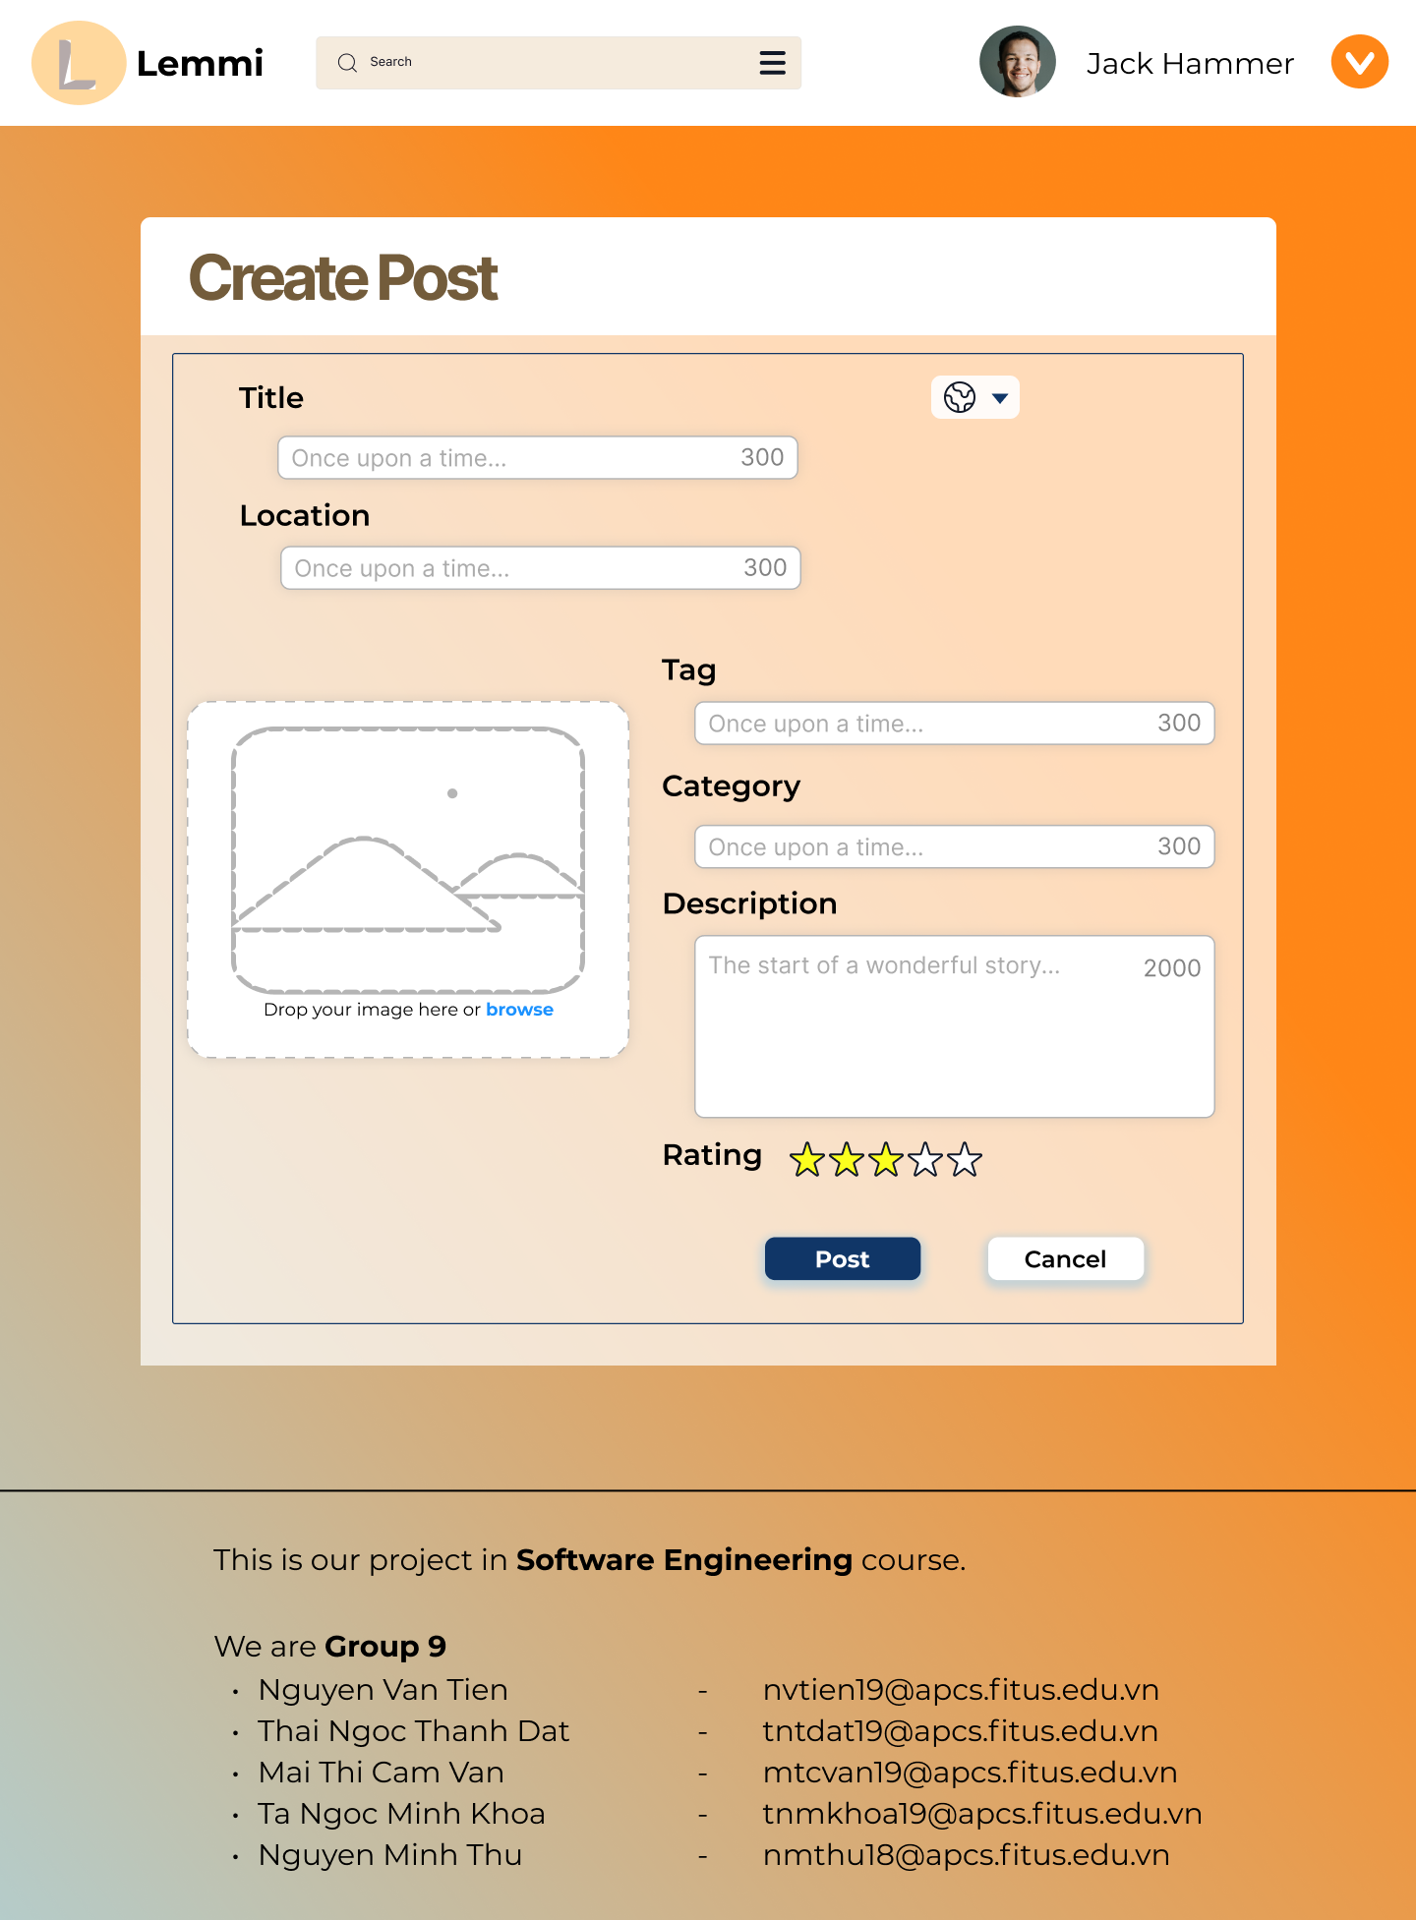

* Purpose: Users can create a review post to share their experience about any stall or restaurant they have visited.
* Show: A big frame with various inputs of the post’s information and an image holder.
* How to use:
* Fill in all required fields for the post and click the “Post” button or cancel if you change your intent.
* Click the button having a down arrow next to the title to select the post’s mode.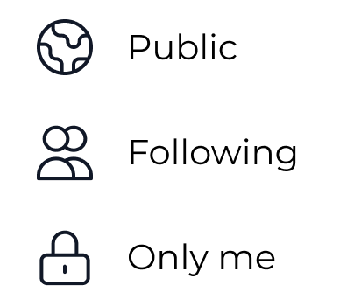

**1.7 Other profile screen:**

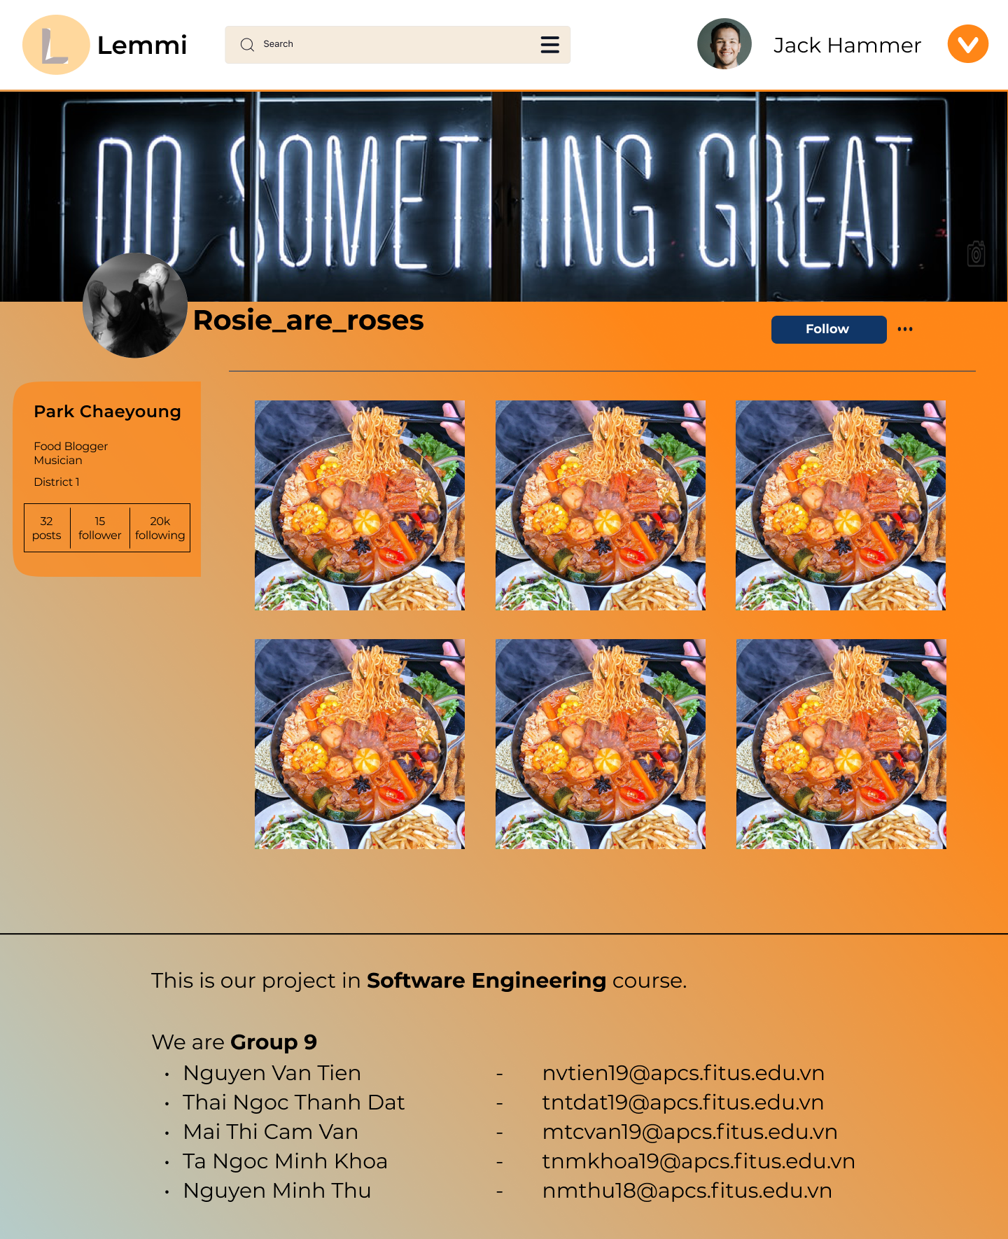

* Purpose: View an account detail such as name, follower, following, the number of posts, and view reviews that have been posted or report profile.
* Shows: List of review posts, block of user info, avatar, cover photo, and their bio.
* How to use:
* If users have not followed this account, they can click the “Follow” button to add them to your following list.
* Click on post to view post detail.
* Click the ⋯ to call report pop-up.

**1.8 Self - profile screen:**

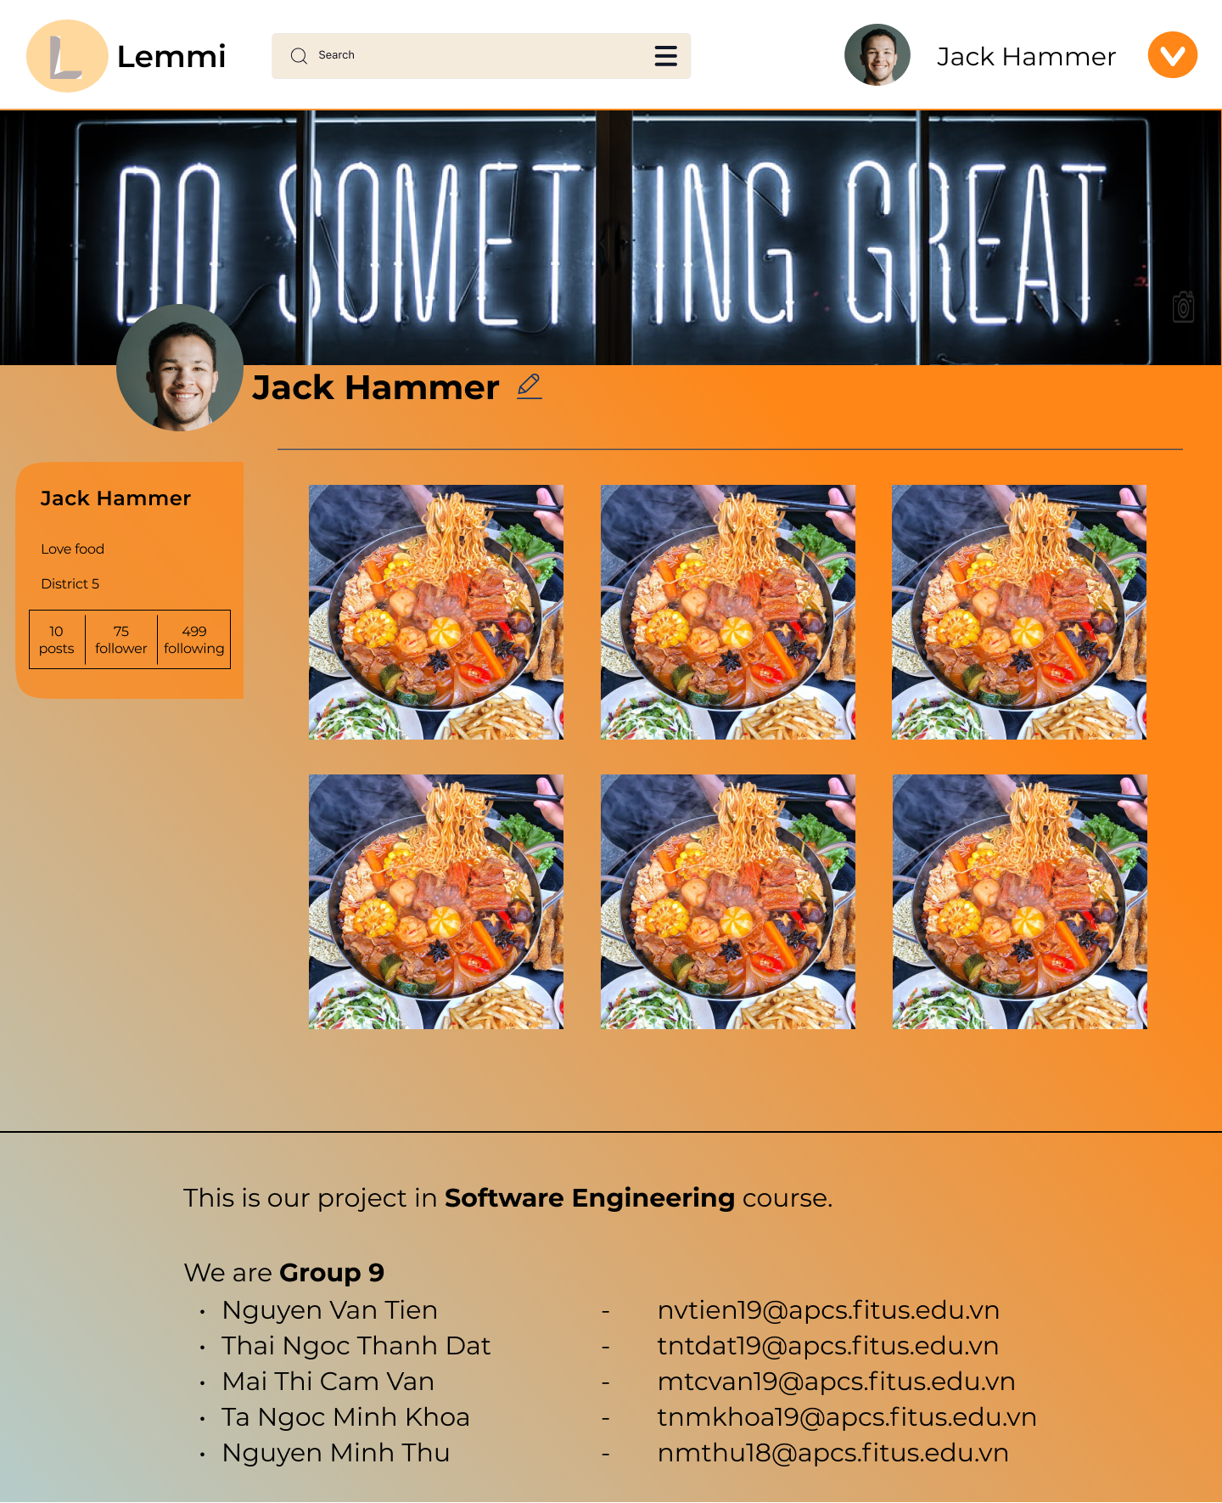

* Purpose: View own account details such as name, follower, following, the number of posts and view reviews that have been posted, where to edit bio, profile information.
* Shows: List of review posts, block of info, avatar, cover photo, and bio.
* How to use:
* Click on post to view post detail
* Click the edit profile button to edit the profile bio.

**1.9 Setting screen/ Edit profile screen:**

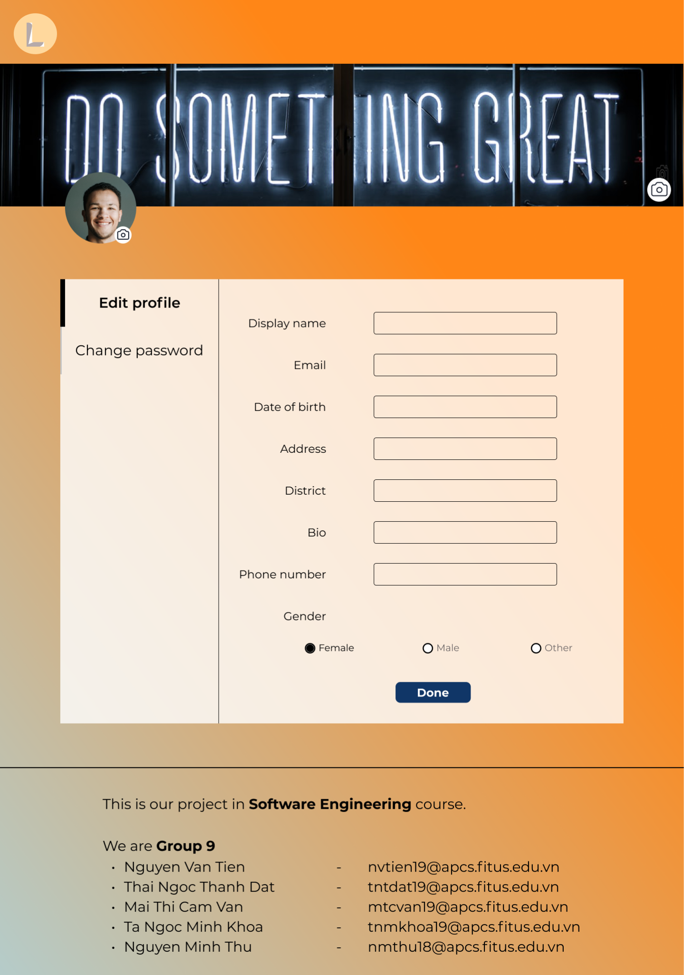

* Purpose: Help users currently change info and want to update their profile.
* Shows: Various input fields for profile info on the right and function section of settings on the left.
* How to use:
* Modify info fields that users want to change and click the “Done” button.
* Click the camera icon on the corner of the photo to change.

**1.10 Change password screen:**

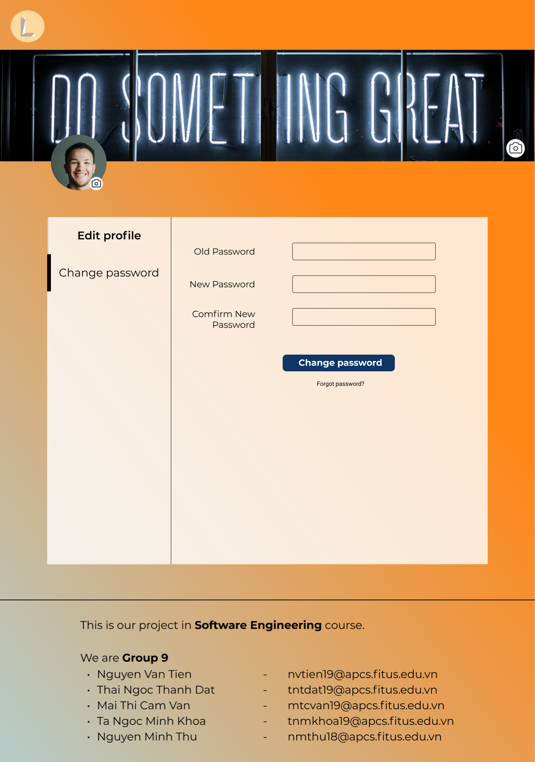

* Purpose: Reduce the risk that hackers may access your account.
* Shows: There are three input fields for the user's old and new password.
* How to use:
* Fill in all three fields, the user can click the “Change password” button to finish the process.
* If users forgot their old password, they can click “Forgot Password?” to move to forgot password screen.

# 

# Extra

* 1. **Dropdown account**
* When authenticated users click the down arrow next to the username.
* How to use:
* Click Profile to move to the profile screen.
* Click Settings to move to the setting profile screen.
* Click Voted to see all review posts which users have voted up or down.
* Click Log out to log out the account, turn into a guest role to visit the website.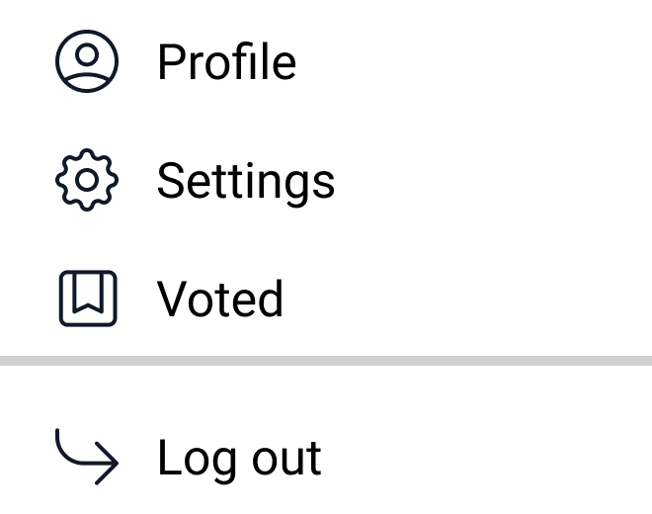
  1. **Label filter panel**
* If users want to search for something, they can or click the search bar to bring up the label filter panel.
* How to use:
* Tick on any criteria you want such as rating or latest.
* Enter a search term in the search bar.
* Click Categories, Tags, or Location to view all labels of each field for choosing.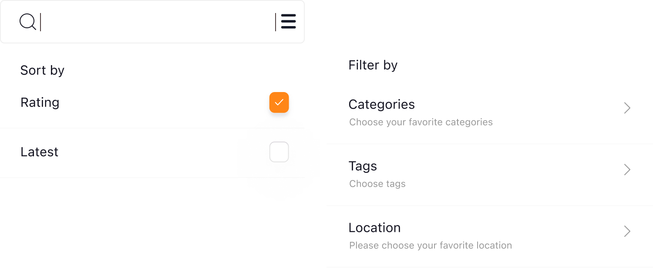

# Video demo

Link: [Folder of video demo](https://drive.google.com/drive/folders/1EWRAuBoSNrJBa3-0xejB28Ol1ImFjwD2?usp=sharing)

# 4. Figma Link

Link: https://www.figma.com/file/rCJBsJk6EhrSdcyxrasCwu/Lemmi-Page?node-id=0%3A1